**Homework 02: Fundamental Concepts II**

**PHYS550 – Quantum Mechanics I**

**Gabriel M Steward**

**September 8-11, 2021**

***Additional Texts Referenced: Introduction to Quantum Mechanics, Griffiths and Schroeter***

**Problem 1.14**

*A spin ½ system is known to be in an eigenstate of* ***S•*** *with eigenvalue ħ/2 where* ***n^*** *is a unit vector lying in the xz-plane that makes an angle γ with the positive z-axis.*

*a) Suppose Sx is measured. What is the probability of getting +ħ/2?*

First of all we need to get the eigenvector out of the dot product, it’ll be quite some time before we can determine Sx probability.

**S** = (Sx, Sy, Sz) and  = ( sinγ , 0 , cosγ ) Which, when taken as a dot product, becomes:

Sxsinγ+0+Szcosγ. Which we can expand in matrix form as:

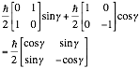

This is our operator, not our *eigenstate*. We want to find the eigenstate with eigenvalue ħ/2and to do that we set up the following relation:

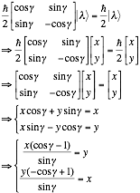

Let us set y=1 and normalize later. Then we have for our eigenstate:



Which simplifies directly by the half angle formula for *tangent*.



And now we can normalize using a large number of trig identities:



So at long last we have the eigenstate. This value is important enough I’m boxing it:

|  |
| --- |
|  |

Now we can attempt to answer the question posed to us. What is the probability of getting spin up for Sx? Well, the probability is given by . a’ is the eigenvalue +ħ/2 and the associated vector is (1/√2, 1/√2) (this is only the case for Sx, the much simpler Sz would have (1,0), for instance.). With this, we can evaluate the probability of spin up:



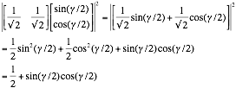

Which is our probability.

|  |
| --- |
|  |

As in structed later, we should check our answers for angles 0, π/2, and π. The above equation produces ½, 1, and ½ respectively. This makes absolute sense because our angle was measured from thez-axis, while Sx is along the x-axis. π/2 is when the vector is pointing *only* in the x direction, and thus guaranteed spin-up. 3π/2 has a zero probability—aka, spin-down.

*b) Evaluate the dispersion of SX, that is . (For your own peace of mind check your answers for the special cases γ = 0, π/2, and π.)*



The dispersion is just the standard deviation, which can also be written as **. The expectation value of an observable is given by . First, find the value for Sx:

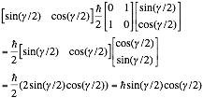

Which at 0, π/2, and π is 0, ħ/2, and 0, respectively: exactly what we would expect.

A similar calculation is performed for the expected value of the square.

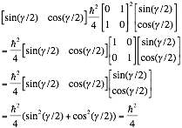

Surprisingly, this is a constant independent of the angle itself.

Regardless, our standard deviation / dispersion is given by:

|  |
| --- |
|  |

Which is a bit hard to intuitively tell if it is correct or not. At the given angles 0, π/2, π we have ħ2/4 , 0, and ħ2/4 respectively, which at least seem reasonable for a standard deviation.

**Problem 1.16**

*A certain observable in quantum mechanics has a 3x3 matrix representation as follows:*



*a) Find the normalized eigenvectors of this observable and the corresponding eigenvalues. Is there any degeneracy?*

The standard method will be used: subtract λ from the diagonal and solve for the zero determinant:

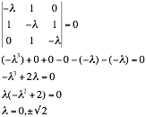

And already we have the first part of our problem: the eigenvalues. Multiplied by 1/√2, of course, given the leading coefficient in the problem.

|  |
| --- |
| 0, 1, -1 |

Now the eigenvectors can be found from the eigenvalues via matrix multiplication:

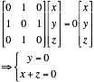

Which means x=-z and thus (1,0, -1) is a valid vector sequence. The normalized version of this is clearly (1/√2, 0, -1/√2). The signs on the numbers could easily be flipped or achieved by multiplying by -1, it’s ambiguous.

Next eigenvalues:

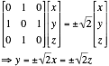

Note how the eigenvalue is the one used without the 1/√2 coefficient added back in. That’s because it’s neater this way, and constants do not change the eigenvectors, only the eigenvalues. In the equations x=z so we can find vectors (1,±√2,1). The normalization for this is not obvious, so we normalize manually.



And by flipping the sign on the middle term we achieve the third vector.

|  |
| --- |
|  |

It is worth noting that √2/2 can be written as 1/√2, but it doesn’t have to be, and neither form is particularly simpler than the other.

And to check, we take the various dot products:

(1)(1/2)+0+(-1)(1/2) = 0 confirmed. For vector 1 and 2. (And vector 1 and 3, as the y term is removed both times.)

(1/2)(1/2)+(√2/2)(-√2/2)+(1/2)(1/2) = ¼ - ½ + ¼ =0 confirmed.

*b) Give a physical example where all this is relevant.*

Let’s take a look at the standard quantum mechanical observables. Position and momentum are out as those are functions, and spin is a vector of size 2, so it doesn’t work either. Total angular momentum when l=1 seems like a great one, since the eigenvalues are 0, 1, and +1. Specifically, it looks like it might be Ly, seeing as x=z at the end.

Looking it up, the above is incorrect. It’s actually Lx. (and it should be multiplied by ħ). Ly is given by:



Regardless, the actual answer is Lx.

|  |
| --- |
| Lx |

Admittedly, this does depend on how the axes are defined.